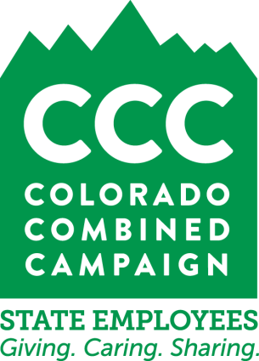
2017-2018 CCC CUSSO Application Information
On our website at www.coloradocombinedcampaign.org/nonprofit-resources.html you’ll find the application form for the 2017-2018 Colorado Combined Campaign for state college and university foundations, along with state service organizations (CUSSO). You’ll find Attachment A in the same place.
Application components
Please take time to review the whole application before you begin filling it out. It’ll save you time in the long run. As you’ll see, the application form is made up of the following parts:
+Important notes and reminders: page 1.
+Space for your contact information: page 3.
+Things you must certify about your organization, based on CCC bylaws: page 4.
+Additional requirements for CUSSOs: page 6.
+The list of and explanation of required application form attachments: page 7.
+Instructions for filling out Attachment A: page 9.
+Worksheet G (state association statement): page 12.
+Worksheet I (explanation of administration and fundraising ratio if higher than 35%): page 13.
Please note that, if you’ve participated in the CCC before, the basic requirements for applying haven’t changed. However, the dates of relevant documents have, so please review this information closely.
Deadline
Application forms must be submitted as hard copies. Attachment A should be provided as a hard copy as well as emailed to apply@coloradocombinedcampaign.org. The deadline for completed application forms and all attachments is 5 p.m. on Friday, February 17, 2017. Given the volume of applicants and the schedule we’re on, there can be no exceptions to this. Page 2 of the application form provides the address to which you can hand-deliver or mail your completed application and its attachments.
Process and schedule
Application forms will be reviewed by the CCC Advisory Committee in March 2017. Applicants will be notified of their status in April 2017. The active fundraising campaign will run from September 2017 to January 2018. Applicants will learn of the funds raised on their behalf in February 2018. Monthly distributions will begin in March 2018 and run for 12 months.
Training conference call
If you have questions or wish to learn more about the application process, please plan to dial in to our conference call. This is scheduled for Tuesday, January 17, 2017, from 12 p.m. to 12:45 p.m. To participate, call 712-432-3066 and use access code 726448. In the meantime, please contact the CCC at 720-420-3210 or apply@coloradocombinedcampaign.org with any needs you might have.
Thank you! We appreciate your interest in the CCC, the workplace giving campaign of Colorado’s state government employees.

